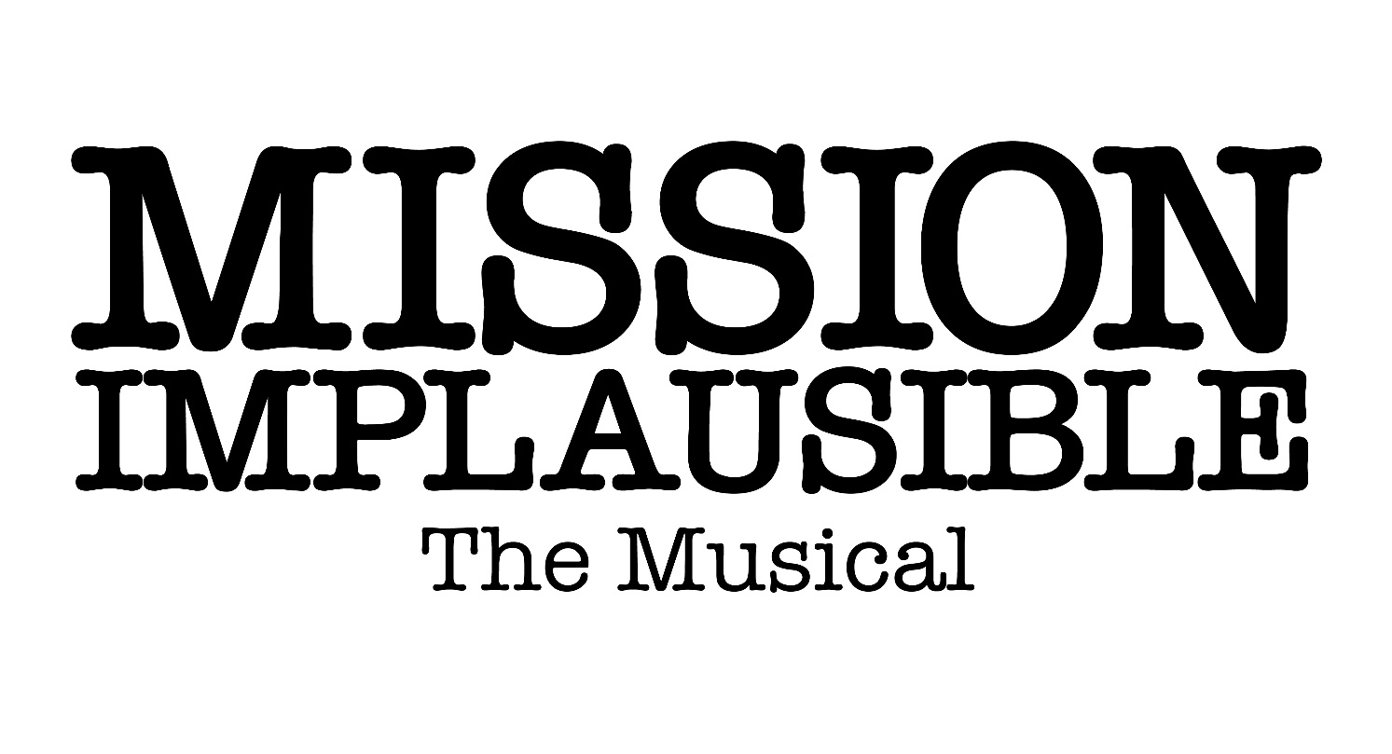
Songs |  | SINGERS
Prologue | MISSION IMPLAUSIBLE (#1/12) | Full Cast
1.1 | SECRET AGENT (#2/14)
1.2 | SONG: YES (#3/16)
1.4 | SERVING THE PEOPLE (#4/19) | PM, April May, Toby Flair, John Minor, Lin Fuss, Edward Maybe, James Gordon, Nicola Herring, Bill Vague, Carla Denver
1.5 | UNLIKELY BADDIES (#5/21) | Miss Abby, Miss Martha
1.6 | THE MAN (#6/23) | Rock, Hard Place, Number Two, Yo-yo, Webb, Snare, Swindle, Grant, Paws, Tic-Tac, Miss Abby, Miss Martha
2.1 | I SPY A SPY (#7/25) | Full Cast
2.2 | NO-ONE LOVES A HENCHMAN (#8/27) | Webb, Snare, Rock, Hard Place
2.4 | TIME TO SAVE THE WORLD (#9/30) | Full Cast

SONG LYRICS
mission implausible (#1/12)
Message decoded, we’re ready to go,
Stakes always high but we’ll go with the flow.
Danger detected, so much on the line,
Down to the wire but we’re there in time.

Fighting the villain and catching the crook,
We’re on a mission to bring them to book.
Clever and daring, audacious and strong,
We’re in the know and we’ll right every wrong.

Mission Implausible, danger ahead.
We’ll save the world,
You’ll sleep safe in your bed.
Mission Implausible, time for a show.
We’ll save the world or at least have a go.

Somebody’s hatching a dastardly plan,
We’re there to crack it if anyone can.
World domination, that’s usually it,
They’ve set their sights and they won’t ever quit.

Epic explosions, eruptions and blasts,
Gadgets and gizmos and driving too fast,
Tropical travels and dangerous scrapes,
Ten second countdowns and last-ditch escapes.

Mission Implausible, danger ahead.
We’ll save the world,
You’ll sleep safe in your bed.
Mission Implausible, time for a show.
We’ll save the world or at least have a go.

Mission Implausible, danger ahead.
We’ll save the world,
You’ll sleep safe in your bed.
Mission Implausible, time for a show.
We’ll save the world or at least have a go.
Mission Implausible.

SERVING THE PEOPLE (#4/19)
Setting the rules to rule the country,
Keeping in mind the bottom line.
Now and then breaking for a party,
Slices of cake and lots of wine.

We’re here serving the people and
Sometimes serving ourselves,
But we try our best or somebody else will instead.

Speaking a lot but saying little,
Beating our own enormous drum.
Looking ahead to each election,
Promising better days to come.

We’re here serving the people and
Sometimes serving ourselves,
But we try our best or somebody else will instead.

We’re the party in number ten,
We got your vote, we’re here again.
Lots of laughter and lots of fun
The best of times have just begun.
Plans for health, for education,
Long-term growth and low inflation,
Going green, albeit slowly,
Pass the crisps and guacamole.

We’re here serving the people and
Sometimes serving ourselves,
But we try our best or somebody else will instead.

We’re here serving the people and
Sometimes serving ourselves,
But we try our best or somebody else will instead.

Unlikely Baddies (#5/21)
Unlikely baddies, that’s how we appear.
Two old dears, what are they doing here?
Shouldn’t they be sitting in a room somewhere,
Finishing their knitting in a rocking chair?

Well shame on you, shame on you.
Just because we’re old doesn’t mean we’re through.
Shame on you, shame on you.
We can do whatever we’re inclined to do.

Unlikely baddies, we know what you think:
Those two dearies have been on the drink.
Look at them careering, what a sight to see.
Shouldn’t they be supping on a cup of tea?

Well shame on you, shame on you.
Just because we’re old doesn’t mean we’re through.
Shame on you, shame on you.
We can do whatever we’re inclined to do.

We can climb up the mightiest mountain,
We can swim in the stormiest sea,
We can visit a night-club and breakdance naked,
And all they’ll see is that we’re elderly.

Unlikely baddies, we’re quite a surprise.
Two old dears of diminutive size,
Who in their right mind would think that we’re spies?
We’re unlikely baddies,
Who look like your grannies,
It’s really a brilliant disguise.

THE MAN (#6/23)
It’s good to be bad,
A little bit naughty,
A tiny bit mad,
And definitely crazy.

I just want to rule the world,
I’ve got a cunning plan.
I just want to rule the world cos I am,
I am the man. He’s the man, he’s the man, he’s the man.
I am the man. He’s the man, he’s the man, he’s the man.

It’s good to be bad,
A little malicious.
A bit of a cad,
And very ambitious.

I just want to rule the world,
I’ve got a cunning plan.
I just want to rule the world cos I am,
I am the man. He’s the man, he’s the man, he’s the man.
I am the man. He’s the man, he’s the man, he’s the man.
I am the man. He’s the man, he’s the man, he’s the man.
I am the man. He’s the man, he’s the man, he’s the man.

I just want to rule the world,
I’ve got a cunning plan.
I just want to rule the world cos I am,
I am the man. He’s the man, he’s the man, he’s the man.
I am the man. He’s the man, he’s the man, he’s the man.
I am the man. He’s the man, he’s the man, he’s the man.
I am the man. He’s the man, he’s the man, he’s the man.

I am the man.

I SPY A SPY (#7/25)
We’re not alone,
There’s somebody watching.
There in the distance, the top of the hill.
Could be a foe,
We may be in danger,
Luckily we’ve got a licence to kill.

And this is where we get to show,
The reason why we’re double o.

I spy a spy with my little eye,
One wrong move, they’ll be saying goodbye.
I spy a spy with my little eye,
One wrong move, they’ll be saying goodbye.

Quiet as mice,
We’re silent and stealthy,
Light on our feet and we’re speedy to boot.
Fearless and smart, and very elusive,
Weapons are loaded, we’re ready to shoot.

And this is where we get to show,
The reason why we’re double o.

I spy a spy with my little eye,
One wrong move, they’ll be saying goodbye.
I spy a spy with my little eye,
One wrong move, they’ll be saying goodbye.

I spy a spy with my little eye,
One wrong move, they’ll be saying goodbye.
I spy a spy with my little eye,
One wrong move, they’ll be saying goodbye.

NO-ONE LOVES A HENCHMAN (#8/27)
No-one ever loves a henchman,
People think that we’re all brawn and not much brain,
With limited attention,
Hence, we’re perfect for the crimin’ly insane.
But we’ve got feelings.

Why is someone else the hero? Hero
Do our lives add up to zero? Zero
Can it really be our destiny to die
In a big explosion?

No-one ever loves a henchman,
All they see is ugly brutes who never smile,
With no chance of redemption,
Stuck forever in the gangland rank and file.
But we’ve got feelings.

Why is someone else the hero? Hero
Do our lives add up to zero? Zero
Can it really be our destiny to die
In a big explosion?

Why is someone else the hero? Hero
Do our lives add up to zero? Zero
Can it really be our destiny to die
In a big explosion?

Time To Save The World (#9/30)
Once, twice, thrice,
When the moment comes to roll the dice,
When you know you need to risk it all,
And the time has come to rise or fall.
Don’t be scared, for the fortunes favour those who dare,
Who discover that to take the step,
Is all that it takes, all that it takes.

No more second guessing if you’re really ready,
It’s time to save the world,
It’s time to save the world.
No more hesitation, no procrastination,
It’s time to save the world,
It’s time to save the world.

Look inside, and you’ll always know you cannot hide,
You will always know you cannot run,
That some things simply must be done.
Through the fear, you will find a way to persevere,
You will find a way to take a step,
It’s all that it takes, all that it takes.

No more second guessing if you’re really ready,
It’s time to save the world,
It’s time to save the world.
No more hesitation, no procrastination,
It’s time to save the world,
It’s time to save the world.

No more second guessing if you’re really ready,
It’s time to save the world,
It’s time to save the world.
No more hesitation, no procrastination,
It’s time to save the world,
It’s time to save the world.
It’s time to save the world.

mission implausible - Reprise (#10/33)
Message decoded, we’re ready to go,
Stakes always high but we’ll go with the flow.
Danger detected, so much on the line,
Down to the wire but we’re there in time.

Fighting the villain and catching the crook,
We’re on a mission to bring them to book.
Clever and daring, audacious and strong,
We’re in the know and we’ll right every wrong.

Mission Implausible, danger ahead.
We’ll save the world,
You’ll sleep safe in your bed.
Mission Implausible, time for a show.
We’ll save the world or at least have a go.

Mission Implausible, danger ahead.
We’ll save the world,
You’ll sleep safe in your bed.
Mission Implausible, time for a show.
We’ll save the world or at least have a go.
Mission Implausible.

